**MOBILE DATA MANAGEMENT (CLASS EXERCISE-3).**

**GROUP MEMBERS.**

**-MOHD TAIF NISAR AHMED ANSARI.**

**-TANYA TANYA.**

1. **Creating a database and inserting data.**

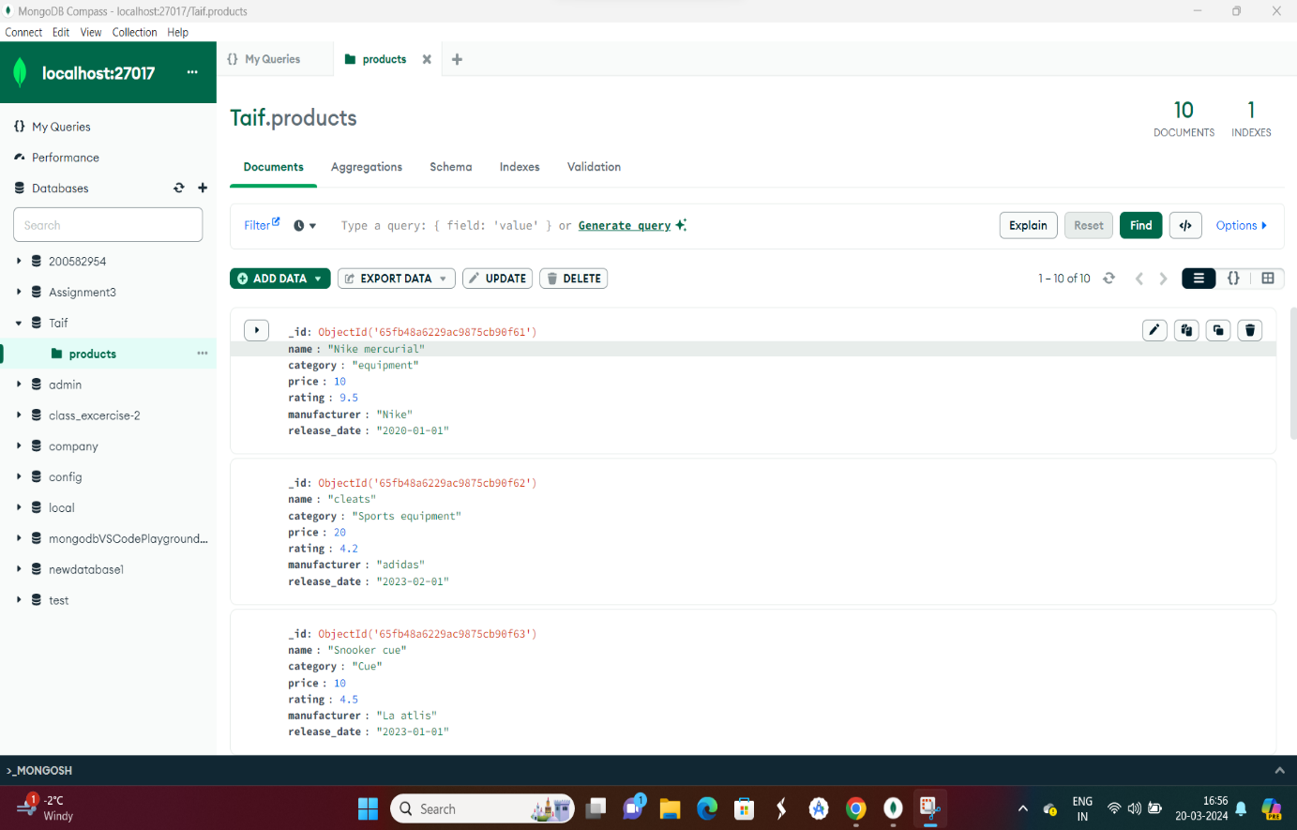

**2.Retrieve details of all products in the collection.**

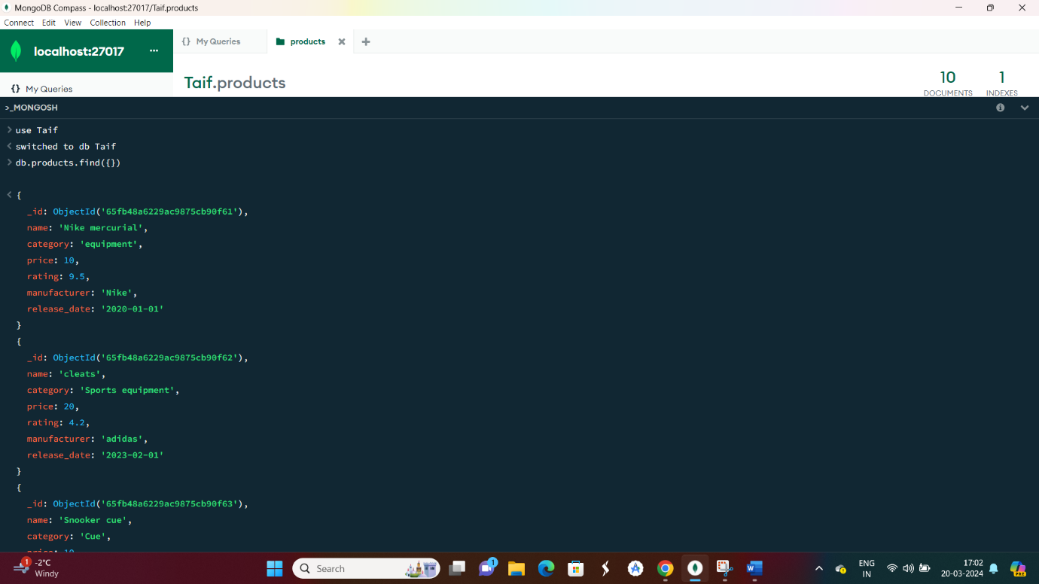

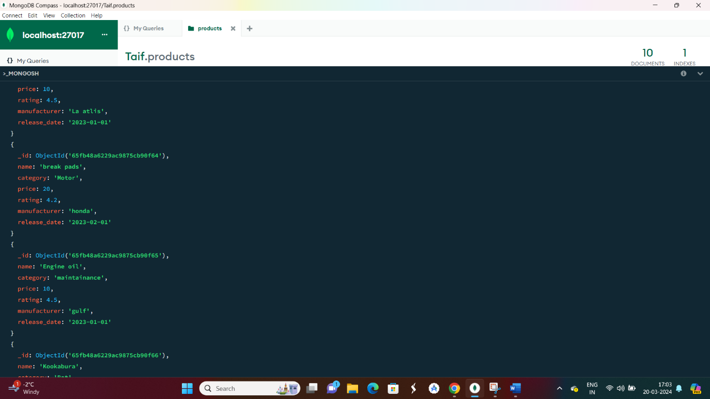

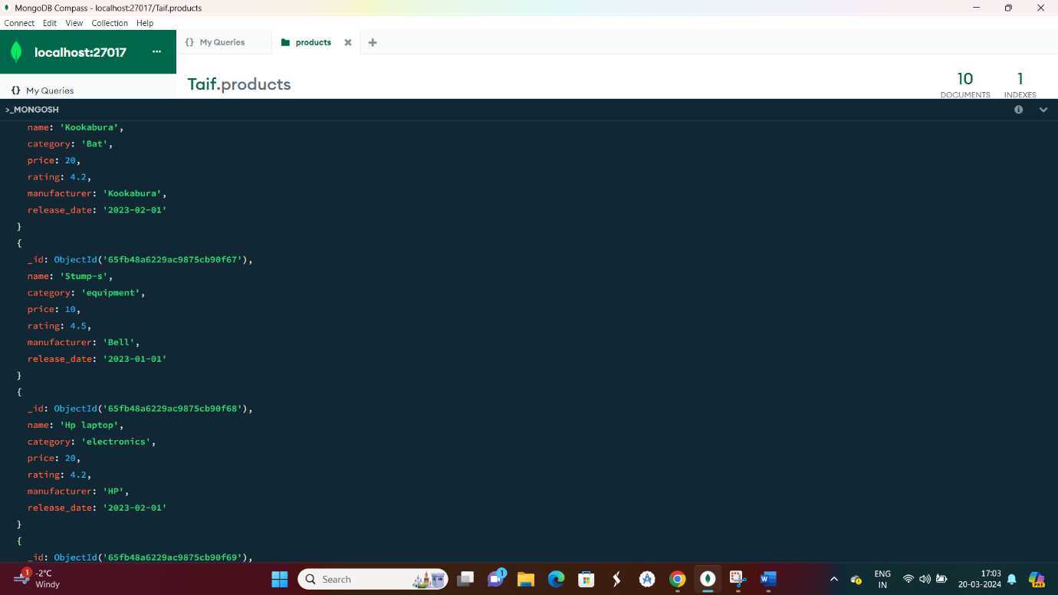

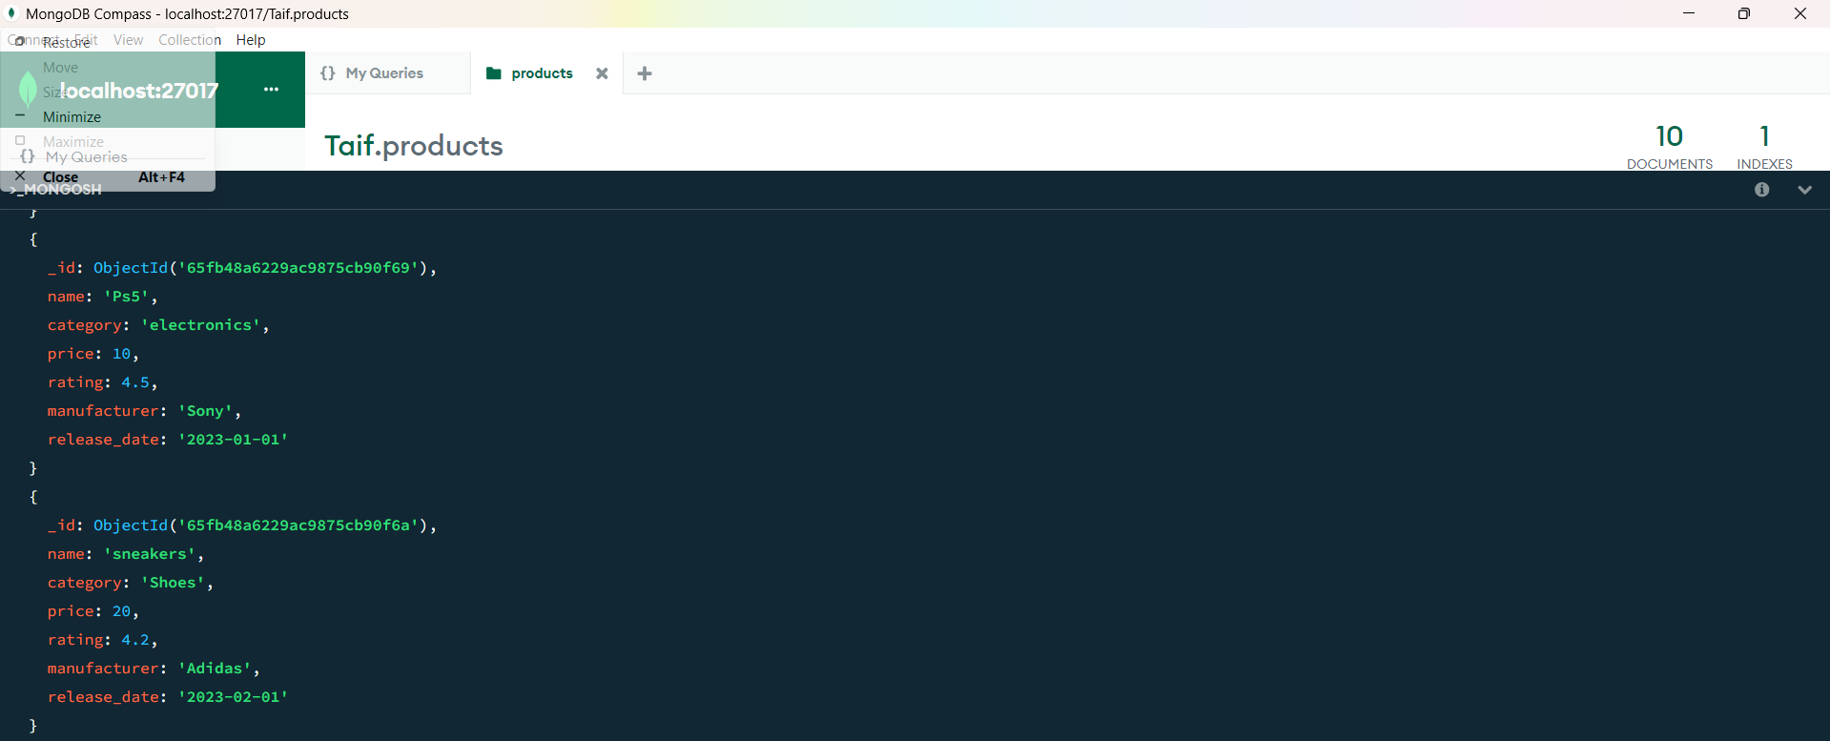

**3.**  **Find a product by name without using limit().**

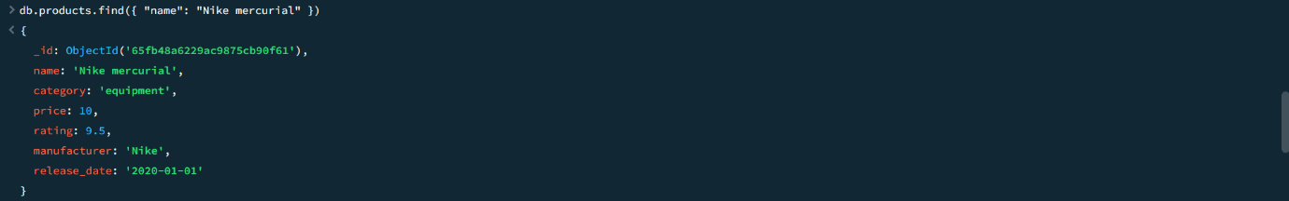

4. **Retrieve the 3rd most expensive products.**

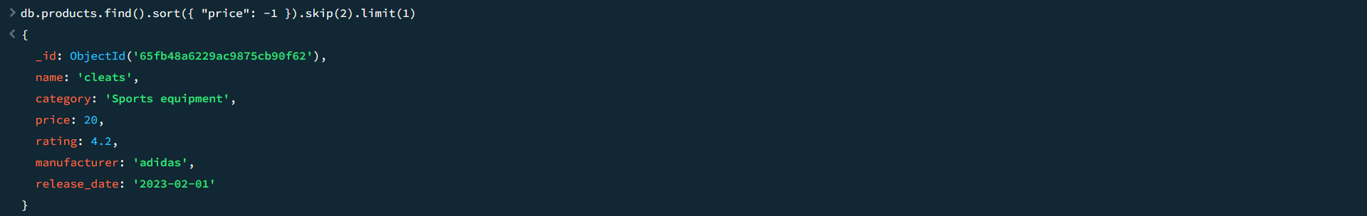

**5. Rename the field 'manufacturer' to 'ProductManufacturer.**

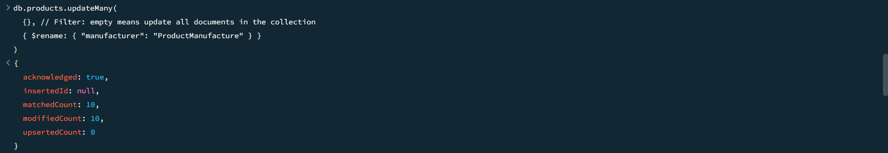

**6. Increase the price of electronics category products by 10%.**

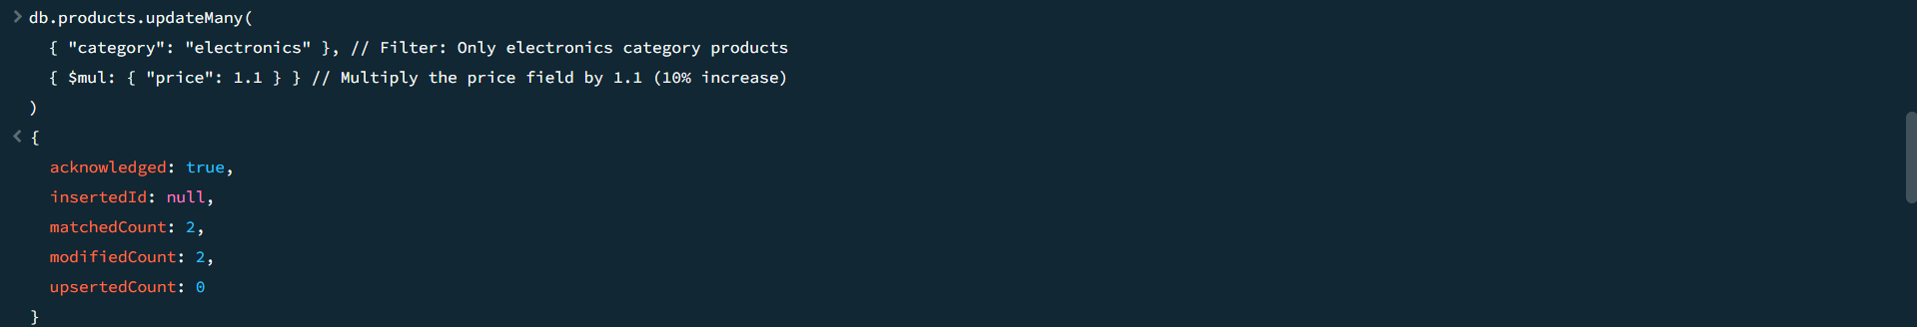

**7. Find products with a price greater than the average price.**

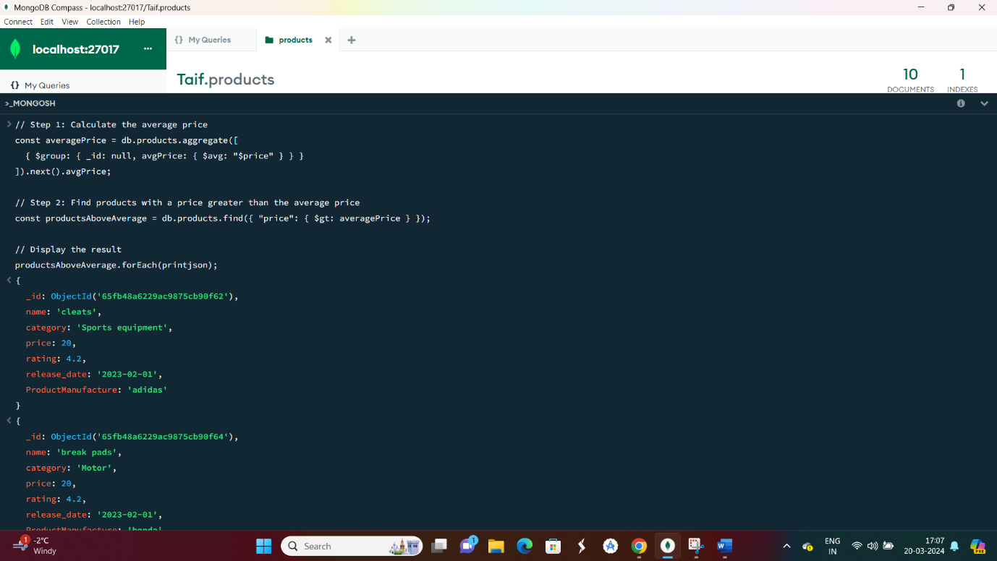

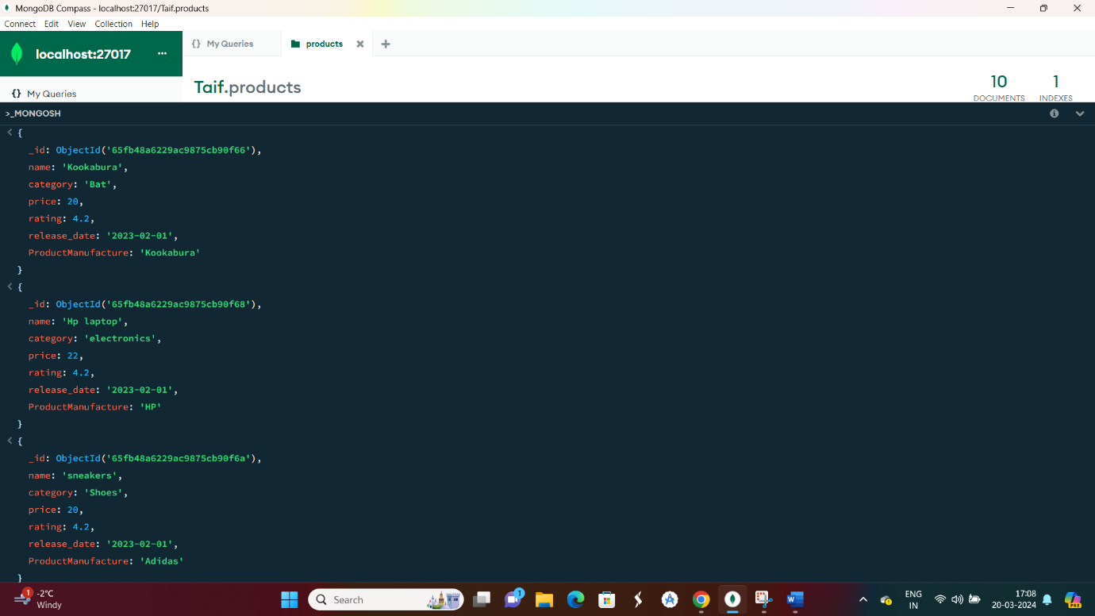

**8. Update the 'release date' of the oldest product to the current date.**

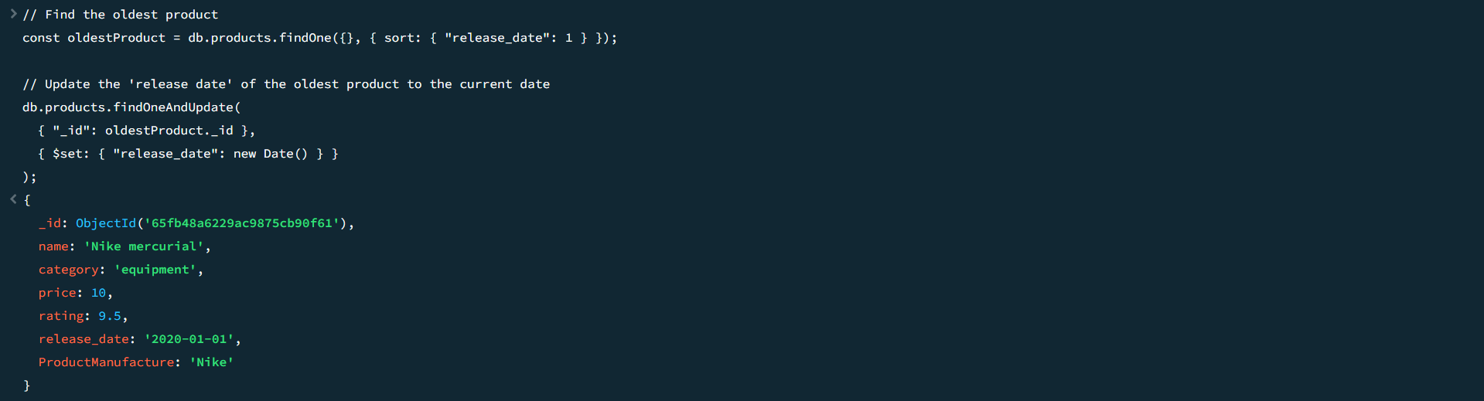

**9. Identify and list premium products with a rating greater than 4.**

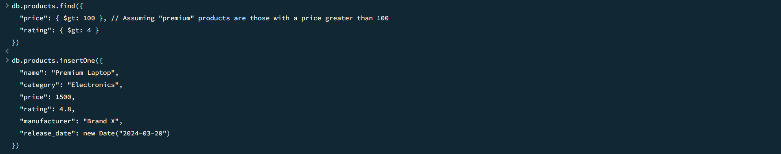

**10.** 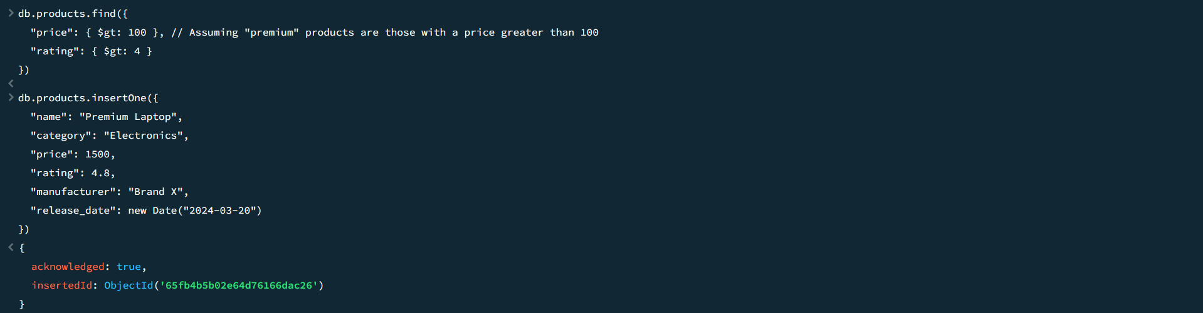

**11. Remove all products with a price less than $20.**

